Sock War 2022
Start Date: Tues, Feb 15 2022.

A department-wide game of tag involving a clean sock as your “weapon”. Each participant of Sock Wars will be assigned a target. A target is eliminated by tagging them with a clean sock and the game is continued following this chain structure until one person emerges as the winner.
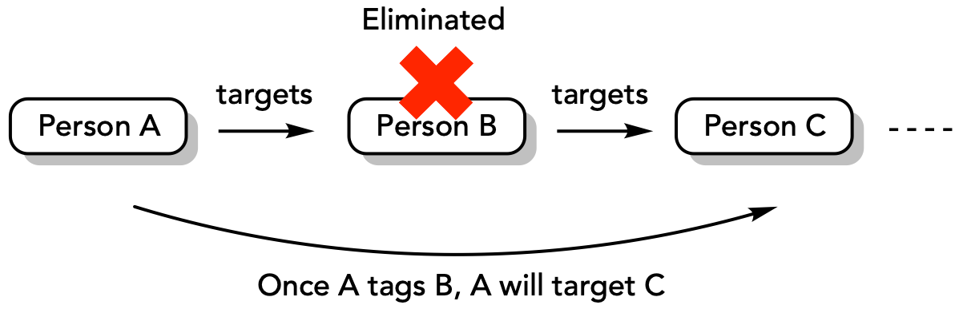

General Gameplay:
- To start: Sign up using this Google Form link:
  - https://forms.gle/PySubzH2PEEtcMR49
- The Game Makers will send each participant an email with the name of your target. This is kept confidential from everyone else. The general targeting scheme is as follow:
  - Person A is assigned Person B to target. Person B is assigned Person C to target.
  - The identity of A is kept from B. (Socker identity remains hidden from their target)
  - Once A tagged B, A and B are responsible for alerting Game Makers of the event, which will then be confirmed. The individuals involved should provide the following information to the Game Makers: The time of socking, if there is a dispute about the socking.
  - Person A now targets Person C. The identity of A is kept from C.
- The game is continued until there’s only one person left standing.
- Game Makers will make an announcement at the end of the week summarizing the week’s elimination. Nothing else will be revealed except the names of the eliminated participants.

Rules and other gameplay elements:
- Safe zones: There are several safe areas in which no one can be socked. Generally, when you’re doing your experiment near the fume hood / glove boxes, or any lab instrument, you are safe from socking.
  - Socking someone during an experiment is a safety hazard. If this happens, the socking will not count and no one gets eliminated. The consequence of this is now the target knows the identity of their Socker. Game continues.
  - Desks in office spaces are not considered as a safe zone.
  - No socking can occur when participants are doing their TA duties. The room in which you are TA-ing is considered a safe zone. As soon as you step outside of that room, you are no longer safe.
  - No socking should disturb any of the following events (both online or in-person). We do not want to create a ruckus in the department.
    - Group meetings
    - Discussion groups (e.g. IDG, ODG, etc.)
    - LMC
    - Any one-on-one meetings with profs.
    - Classes
  - Washrooms

Game Makers reserves the right to remove or add safe zones at any time.

If a socking occurs in the safe zone, you may bring this to the Game Makers attention and we will determine the appropriate consequences. If it reaches an unprofessional level or an unsafe work practice (e.g. disturbing someone’s group meeting or during TA) it will result in disqualification.

- Safety Item: Safety items are items visibly worn/held by individual participants of Sock Wars that gives them immunity from socking/getting eliminated. Safety items are changed weekly, this announcement will be made by the Game Makers via an appropriate channel. There will be a buffer period starting midnight of the day it was announced until the next morning at 8:00am. Generally, safety items get increasingly difficult and embarrassing to wear as the game progresses! This item is not provided by the Game Makers. Each participant is responsible for their own safety item. Game Makers reserve the right to remove or add safety items at any time. Non-negotiable.
  - Safety items can’t be removed by anyone else other than the individual wearing/carrying them.
  - Safety items should not cost money. We will not assign them to wear a certain brand of clothing in order to be safe! Creativity is encouraged. A prize will be given to individuals with the most creative safety item.

- Other possible elements to gameplay: Game Makers will announce these modifications ahead of time for a given week. Valid through a period of time that the Game Makers determined.
  - Resurrection events: Around halfway through the game we might introduce a resurrection event. Players who have been eliminated will get a chance to be reintroduced into the game under certain conditions.
  - Advantage token: Socking a Game Maker will allow them to gain advantages, such as choosing future safety items, knowing the person targeting them, etc.
  - Hiding an item / Treasure hunt: The person who finds this item will be granted immunity for 1 week. No safety item required. Safe from any socking!

- This event is only for UBC Chemistry Faculty, Staff, and Graduate Students who are currently enrolled in the current academic year, present on campus on a regular basis (Unfortunately, students who are working from home most of the time will not be able to participate)

- Winner and prizes:
- There can only be one winner of Sock Wars. Alliances are allowed, but it should still result in an individual winning the game and not a team.
- Prizes!!!!
  - $100 gift card- Winner
  - $20 each for:
    - Most Creative Socking
    - Most Creative Safety Item
    - Most Dedicated Player
    - Best Eulogy
    - Worst Betrayal

